 |  |  |  | DISTRIBUTION
PROJECT | UNR-Mathewson | REPORT # | 007
LOCATION | Reno, NV | TRIP DATE | 06/10/2024
PROJECT # | A9941.01 | ENGINEER/Observer | Anand Mourougassamy
CLIENT | LMN Architects | TODAY’S DATE | 6/12/2024
CONTRACTOR | Clark Construction | PAGE | 1 OF 4

OBSERVATIONS/ACTIVITY
Time: 10:00 am
Weather: Sunny 85 °F
Present: Clark Construction – Brian Peart, Chase Johnson
LMN Architects – David Donaldson
Magnusson Klemencic Associates – Hannah Bonotto, Anand Mourougassamy

Clark, LMN, and MKA walked the UNR Mathewson site to observe the in-progress brick ledger framing on the east perimeter and steel framing near core 3.

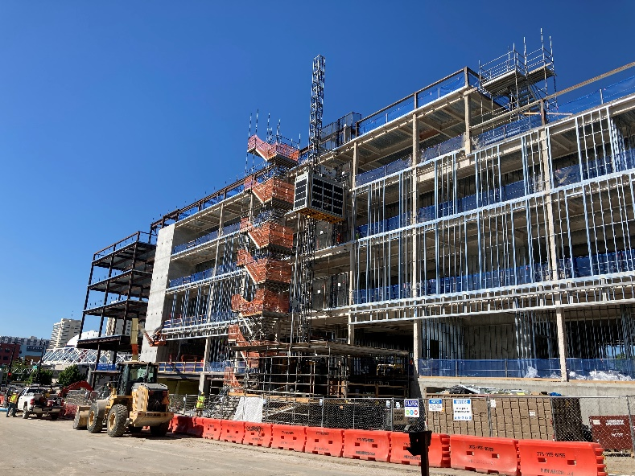
Figure 1. Overall view of the east perimeter, view looking southeast

- MKA observed the progress of framing support for the brick ledgers at grid A between grids 6-10. MKA understands the low double angle kickers will be installed prior to brick placement. The steel framing appeared to be in general conformance with the contract documents.  Action: None. | 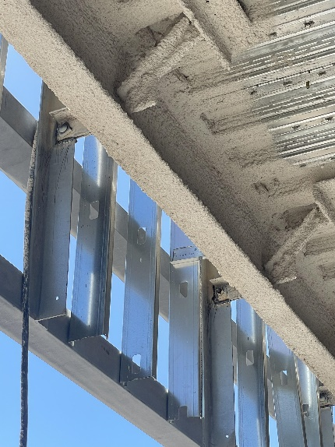  Figure 2. View of Brick Ledger Type B Framing showing WT connection back to Double Angles
- MKA observed stud pieces potentially used as shim between metal framing and beam bottom flange at Grid D.1 along west perimeter.  Action: Contractor to confirm any temporary connection from stud framing to beam bottom flange to be removed prior to curtain wall placement. | 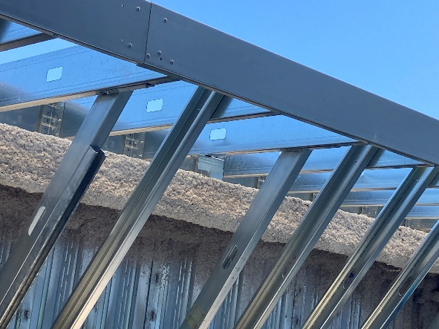  Figure 3. View of Metal Stud Framing at West Perimeter (Grid D.1)

- MKA observed the in-progress erection of the Dean’s Terrace steel.  Action: None. | 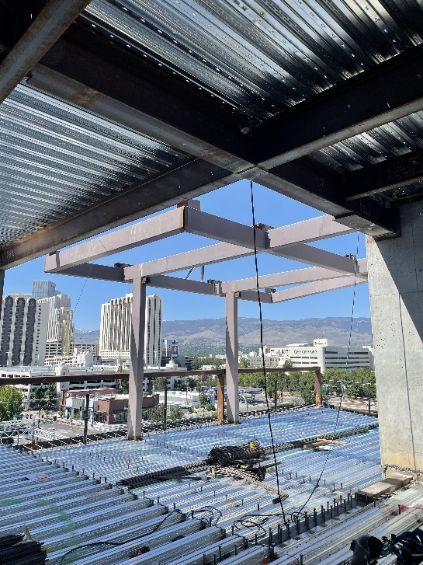  Figure 4. Dean’s Terrace steel framing looking southwest
- MKA observed concrete voids at core wall opening at level 3 and 5 of Core 2 with exposed coupling beam reinforcement.  Action: Contractor to follow 03 30 00 specification section 3.10 and perform concrete repair using approved grout and follow steps per method of repair as approved by EOR. | 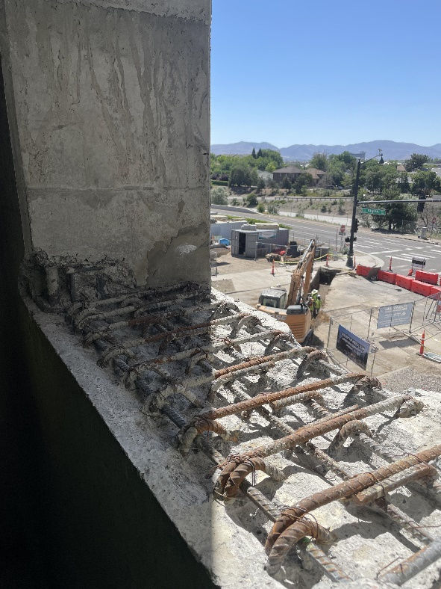  Figure 5. Concrete voids at core wall opening on level 3 of Core 2
- MKA observed elevator rail support posts at Roof level at core 2, which were not aligned with the installed embed plates.  Action: Contractor to provide RFI with clarifying dimensions for field fix at this location. | 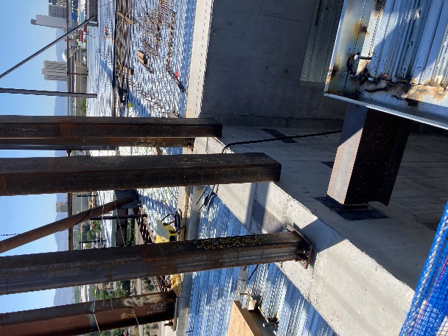  Figure 6. Elevator rail support posts at Roof level of Core 2.
- MKA observed deck ledger anchors to be installed at an angle at locations where installation was hindered by the presence of rebar.  Action: Contractor to confirm that failed anchor holes to be fully packed with grout or epoxy mix at locations where the failed hole sits directly below the installed anchor. | 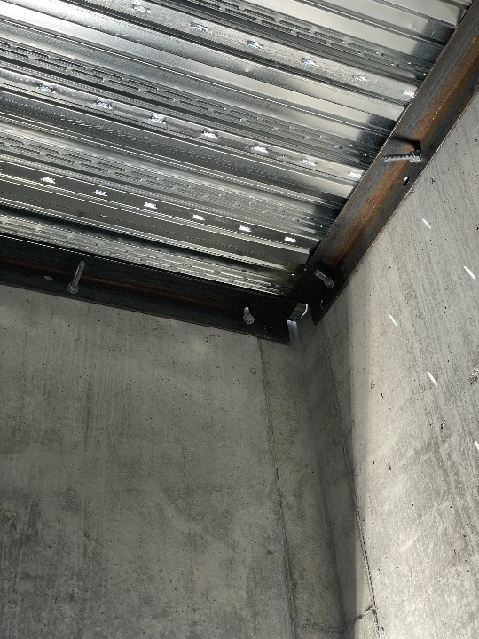  Figure 7. Deck Ledger Anchors installed at an angle at Roof level of Core 3. View looking northeast corner inside Core 2.

I:\UNR_Mathewson\Construction Admin\FieldReports\20240612_UNR_MKA Construction Observation Report_007.docx

